# Section 15-3: Ninth to Tenth Vassa (Age 43–44)

In the previous section (15-2), we explored how the Buddha spent his sixth, seventh, and eighth rainy seasons in three different locations. In this section, we will discuss the places where he spent his ninth and tenth vassa.

# Ninth Vassa

By the time of his ninth rainy season, we assumed that the Buddha was around forty-three years old. Various scriptures mention the Blessed One residing in the Kosambī region during this period. However, they do not explicitly state that he spent the entire ninth vassa there. Based on the following sources, we can reasonably conclude that the Buddha spent this rainy season in Kosambī:

1) “The ninth near Kosambī “ (*navamaṁ Kosambiyaṁ) [1]*

2) “The Ornament of the Three Worlds, the Victorious Bird-King, having destroyed the arrogance of a great many snake-like sectarians, who had various opinions, in the ninth Rains Retreat, dwelt in the agreeable, very fair, Silk-cotton Wood near to Kosambī .” [2] (**nānāmatātibahutitthiyasappadappaṁ- hantvā tilokatilako navamamhi vasse  
vāsaṁ akāsi rucire atidassanīye- kosambisimbalivane jinapakkhirājā).**

3) “The Buddha spent his ninth rainy season in Kosambī. Three wealthy men from Kosambī—Ghosaka (Ghosita), Kukkudha, and Pavarika—heard of the Buddha’s presence and travelled to Jetavana Monastery in Sāvatthī to pay their respects. Deeply inspired, they invited the Blessed One to visit Kosambī. In anticipation of his arrival, each of them constructed a grand monastery: Ghosaka built ‘Ghositārāma,’ Kukkudha (also known as Kukkuṭa) established ‘Kukkudārāma,’ and Pavarika created ‘Pāvārikāmbavana,’ a mango grove monastery.”[3]

According to Tradition the Buddha arrived from Jetavana Monastery to Kosambī region with a large gathering of Sangha. The three wealthy patrons took turns inviting the Buddha and the Sangha to their homes for a meal. On the first day, the Blessed One and his disciples dined at Ghosaka’s residence, after which he formally received Ghositārāma as a monastery. On the second day, Kukkudha hosted the Buddha and the Sangha, offering them Kukkudārāma as a place of residence. Finally, on the third day, the Blessed One visited Pavarika and his family, who presented Pāvārikāmbavana, the mango grove, as a dwelling for the Buddha and the Sangha. [4]

## Where is Kosambī?

During the time of the Buddha, Kosambī was the capital of the Vatsa (also known as Vamsa) kingdom. It was located on the northern bank of the Yamunā River and served as a major centre for river trade. According to tradition, Kosambī was a prosperous city, home to many wealthy merchants. As previously mentioned, three prominent businessmen from this city generously donated three monasteries to the Buddha and the Sangha.

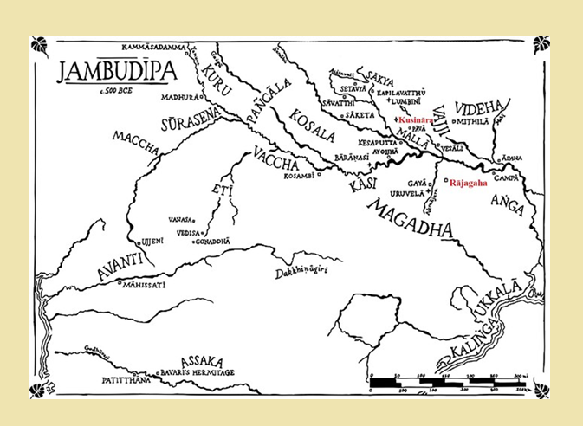

**Location of Kosambī - During the time of the Buddha[5]**

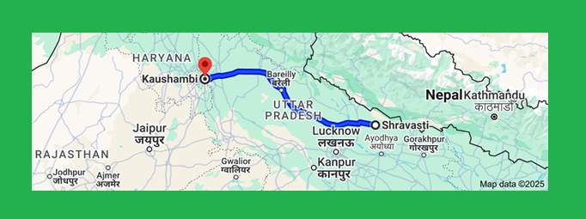

**Modern day map of Kosambī (Kaushambi),** Distance from Shravasti to Kaushambi is 564.8km **[6]**

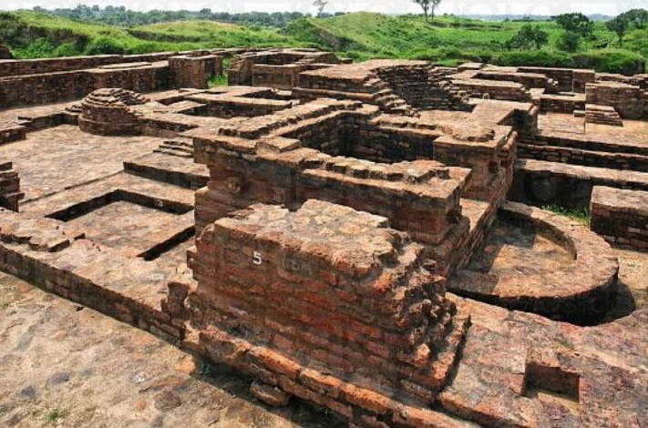

**Ruins of Ghoshitarama monastery in Kosambī[7]**

## The Three Monasteries Donated in Kosambī

### Ghosita Monastery

According to the scriptures, numerous discourses were delivered by the Buddha and his prominent disciples at Ghosita Monastery in Kosambī. One significant discourse, the *Kosambī Sutta* (MN 48), which addresses a well-known dispute among the Sangha, was preached by the Blessed One while residing at this monastery. (The key teachings from this sutta are discussed below.)

The following excerpts from the *Udana* confirm that the Buddha resided at Ghosita Monastery in Kosambī.

|  |
| --- |
| *“One time the Gracious One was dwelling near Kosambī, in Ghosita's Monastery. Then at that time the*  *Gracious One was living beset by monks, and nuns, and male lay followers, and female lay followers,*  *and kings, and king's ministers, and sectarians, and sectarians’ disciples, he lived beset, unhappy, and*  *uncomfortable…”* **Udana (Ud:4.5)**  *“At one time the Gracious One was dwelling near Kosambī, in Ghosita's Monastery. Then at that time*  *when King Udena had gone to the pleasure park, the inner quarters of the palace were burnt down,*  *and five hundred women died with Queen Sāmāvatī at their head. ”* **Udana (7.10)** |
| The following suttas also mention the Buddha residing at Ghosita Monastery:  MN 76, MN 85, MN 128, and AN 4:243.  Additionally, in SN 35:29 (*Ghosita Sutta*), Venerable Ānanda is recorded as meeting the householder  Ghosita while staying in Kosambī and delivering a discourse to him on the diversity of elements. |

Kukkudharama (Kukkutarama)[8]

According to the scriptures, Kukkutarama (also known as *Cock’s Park*) was not located in Kosambī but in the city of Pataliputta (present-day Patna) in Magadha during the time of the Buddha. The following scriptures confirm this:

The *Vinaya Pitaka* mentions an event that took place in this monastery, which was situated in Pataliputta:

*“On that occasion there were a number of senior monks—Venerable Nilavāsī, Venerable Sāṇavāsī, Venerable Gotaka, Venerable Bhagu, and Venerable Phaḷikasantāna—staying at Pāṭaliputta in the Kukkuṭa Monastery. The monks from Rājagaha went to Pāṭaliputta to ask them…”[9]*

In the Aṭṭhakanāgara Sutta(MN:52) there is a passage referring to Kukkuṭa’s Park in Pāṭaliputta

“Now *on that occasion the householder Dasama of Aṭṭhakanāgara had arrived at Pāṭaliputta for some business or other. Then he went to a certain bhikkhu in Kukkuṭa’s Park , (Kukkuṭarama) and after paying homage to him, he sat down at one side and asked him: “Where does the venerable Ānanda live now, venerable sir?”*

In Maggasamyutaa (SN45) the following suttas also mentioned about Cock’s Park in Pāṭaliputta

*“Thus, have I heard. On one occasion the Venerable Ānanda and the Venerable Bhadda were dwelling at Pāṭaliputta in the Cock’s Park” .(*SN45:18, SN45:19, SN45:20)

Satipaṭṭhānasaṃyutta (SN47) also mentioned about Cock’s Park in Pāṭaliputta. (SN47:21, SN47:22 and SN47:23.)

### Pāvārika’s Mango Grove (*Pāvārikāmbavana*)

The *Dīgha Nikāya* mentions that Pāvārika’s Mango Grove was located in Nālandā, in the Magadha province. Several suttas reference the Buddha and his disciples residing there at different times, including: *Kevaddha Sutta* (DN:11), *Mahāparinibbāna Sutta* (DN:16)

*Sampasādanīya Sutta* (DN: 28)

A sutta in the *Saṁyutta Nikāya* further confirms that Pāvārika’s Mango Grove was situated in Nālandā:

*“ On one occasion the Blessed One was dwelling at Nālandā in Pāvārika’s Mango Grove. Then the householder Upāli approached the Blessed One.”* (SN35: 126)

According to the scriptures, the following suttas were also delivered in Nālandā at Pāvārika’s Mango Grove: *SN 42:6, SN 42:7, SN 42:8, SN 42:9.*

Sources indicate that the grove belonged to a wealthy merchant (*setthi*) named Pāvārika, who is distinguished from another setthi of the same name in Kosambī by the title *Dussapāvārika* (e.g., DA.ii.873; MA.i.540; SA.iii.169). Pāvārika of Nālandā, having heard the Buddha’s teachings, became his follower and built a monastery for the Buddha and the Saṅgha within his mango grove. This monastery became known as *Pāvārikāmbavana* (DA.iii.873; MA.ii.594; SA.iii.169).

Based on this information, it is clear that *Ghosita Monastery* was definitely located near Kosambī. However, the exact locations of *Kukkutarāma* and *Pāvārikāmbavana* remain uncertain. It is possible that two individuals named *Kukkuta*, one from Kosambī and the other from Magadha, built monasteries with the same name, *Kukkutarāma*, and offered them to the Buddha and the Saṅgha.

According to the scriptures, the only confirmed *Kukkutarāma* during the Buddha’s time was in Pāṭaliputta (Magadha). Likewise, there may have been two wealthy donors named *Pāvārika*—one from Kosambī, who donated a mango grove while the Buddha was dwelling there, and another from Nālandā, who also offered his mango grove to the Buddha.

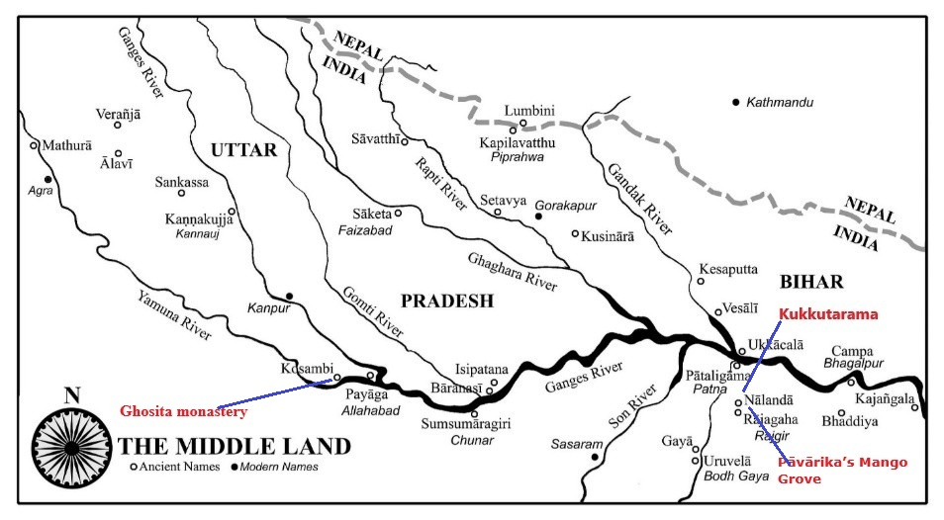

**Map showing the location of the 3 monasteries. [10]**

## Significant Event Before the Ninth Rainy Season

The *Māgaṇḍiya Sutta* (*Snp 4.9*) in the *Sutta Nipāta* recounts an encounter between the Buddha and a brahmin named Māgaṇḍiya, in which the Blessed One imparted Dhamma teachings to him. While the sutta itself does not specify the time or location of this meeting, the commentary suggests that it took place while the Buddha was traveling to Kosambī. He was on his way there in response to an invitation from three wealthy men of the city, who had requested him to spend his ninth rainy season in Kosambī.

### Brief Account of the Event

Māgaṇḍiya, a brahmin from the Kuru country, had a wife and a remarkably beautiful daughter. One day, as the Buddha was passing through the region on foot, he stopped to rest. Upon seeing the Buddha’s footprints, Māgaṇḍiya immediately recognized them as those of a great man. Excited, he called his wife and daughter and proposed that his daughter be given in marriage to the Buddha.

The Buddha, however, declined the proposal, explaining that he had renounced all sensual pleasures. He then spoke the following words:

*“Having seen Taṇhā, Aratī, and Ragā,[11]  
I did not have any desire for sexual intercourse,  
so why should I desire this, full of urine and faeces?  
I would not wish to touch her even with my foot”*

*“Having left home to roam without abode,  
in the village the muni is intimate with none.  
Void of sensual pleasures, without preferences,  
he would not engage in contentious talk with people”*

*“For one detached from perception there are no knots;  
for one liberated by wisdom there are no delusions.  
But those who have grasped perceptions and views  
wander in the world creating friction.”[12]*

Having realized the Dhamma, the Brahmin Māgaṇḍiya and his wife sought refuge in the Buddha and attained the noble state of non-returners.

However, their daughter showed no interest in the Buddha’s teachings. Proud of her beauty, she was enraged when the Buddha described the human body as merely a vessel filled with urine and filth. Later, she became the queen of King Udena of Kosambī. When the Buddha resided there, she repeatedly attempted to trouble both him and the Sangha. Harbouring deep resentment, she eventually orchestrated a plot to have King Udena’s other queen, Sāmavati, and her entourage burned to death after Sāmavati had taken refuge in the Buddha. [13]

At that time, the Buddha was residing in Kosambī. The monks recounted the incident as follows: [14]

*“Here, reverend Sir, when King Udena had gone to the pleasure park, the inner quarters of the palace were burnt down, and five hundred women died with Queen Sāmāvatī at their head. What is the destination of the female lay followers, reverend Sir, what is their future state?"*

The Blessed One replied:

*“There are in this, monks, female lay followers who are stream-enterers, there are once-returners, there are non-returners, —none of those female lay followers died, monks, without having attained some result." [15].*

Recognizing its significance, the Buddha proclaimed this exalted statement:

*“ The world, in bondage to delusion,  
is looked on as being beautiful,  
The fool, in bondage to cleaving,  
is surrounded by darkness.  
It seems like it is eternal,  
but there is nothing to hold to for the one who sees." [16]*

## Significant events happened during the nineth rainy season

## The Dispute at Kosambı̄

While the Blessed One was residing at Ghosita’s Park in Kosambī, a dispute arose within the Sangha. [17] What began as a minor misunderstanding over a trivial disciplinary rule soon escalated into a serious conflict. The disagreement spread rapidly, dividing not only the monks but also the lay community of Kosambī into two opposing factions, each taking sides in the quarrel. [18]

Seeing the growing discord, the Buddha summoned the monks involved in the dispute. With compassion and wisdom, he addressed them, seeking to restore harmony within the Sangha.

*“So, bhikkhus, when you take to quarrelling and brawling and are deep in disputes, stabbing each other with verbal draggers, on that occasion you do not maintain acts of loving-kindness by body, speech, and mind in public and in private towards your companions in the holy life. Misguided men, what can you possibly know, what can you see, that you take to quarrelling …and stabbing each other with verbal daggers? That you can neither convince each other nor be convinced by others, that you can neither persuade each other nor be persuaded by others? Misguided men, that will lead to your harm and suffering for a long time .”[19]*

The *Kosambiya Sutta* (MN 48) recounts how the Buddha taught the divided Sangha six qualities that foster love, respect, and harmony. Additionally, he elaborated on the seven exceptional types of knowledge possessed by a noble disciple who has attained the fruit of stream-entry. A brief summary is provided below:

### The Six Principles of Cordiality

*“Bhikkhus, there are these* ***Six Principles of Cordiality*** *(Cha dhammā sārāṇı̄yā ) that create love and respect and conduce to cohesion, to non-dispute, to unity”*

**They are:** (1-3) to maintain bodily…verbal…mental acts of loving-kindness both in public and in private towards his companions in the holy life. 4) share things in common with his virtuous companions in the holy life; without making reservations, he shares with them any gain … obtained in a way that accords with the Dhamma, including even the mere contents of his bowl. 5) dwells both in public and in private possessing in common with his companions in the holy life those virtues that are unbroken…commended by the wise… and conducive to Samādhi. 6) dwells both in public and in private possessing in common with his companions in the holy life that view that is noble and emancipating, and leads one who practises in accordance with it to the complete destruction of suffering—Right View. [20]

Seven Extraordinary knowledges (seven great reviewing knowledges-*mahāpaccavekkaṇāṇa*) of a stream-winner: [21]

1) the knowledge that there is no obsession in the mind which prevents him to see things as they actually are 2) the knowledge that when he possesses the Right View and cultivate it, he can personally obtain serenity and quenching 3) the knowledge that there is no recluse outside the Buddha’s dispensation possess the Right View 4) the knowledge that he possesses character of a person who has the Right View 5) the knowledge that though he may engaged in various matters for the companions of his spiritual life, but has keen regard from higher virtue…training …mind (this is the character of a person who possesses right view) 6) the knowledge that he possesses the strength of a person who has the Right View :when the Dhamma and Discipline proclaimed by the Tathāgata is being taught, he heeds it, gives it attention, engages it with all his mind, hears the Dhamma as with eager ears 7) the knowledge that he possesses the strength of a person who has the Right View: when the Dhamma and Discipline proclaimed by the Tathāgata is being taught, he gains inspiration in the meaning, gains inspiration in the Dhamma, gains gladness connected with the Dhamma.

The Buddha concluded thus:

*“When a noble disciple is thus possessed of seven factors, he has well sought the character for realisation of the fruit of stream-entry. When a noble disciple is thus possessed of seven factors, he possesses the fruit of stream-entry*.”[22]

According to the *Vinaya Piṭaka*, the Buddha attempted to resolve the dispute between the two factions and addressed them as follows:

*“Enough, monks, don’t quarrel and dispute.”[23]*

They refused to accept the Buddha's compassionate advice, proving his teaching that when one is blinded by pride, it becomes impossible to discern right from wrong. Instead, they responded:

*“Wait, Sir, you’re the Lord of the Teaching. Be at ease and enjoy the happiness of meditation. We’ll face the consequences of this quarrelling and disputing.” [24]*

The Buddha repeated his appeal to the monks three times, but each time, they responded in the same way.

Seeing their stubbornness, he then shared a Jātaka story from one of his past lives, recounting how his father had advised him never to act out of hatred.

‘*My dear Dīghāvu, see* neither *long nor shor*t. *For hatred never ends through hatred; hatred only ends through love.’[25]*

### Brief Account of the Story:[26]

Once, in the city of Benares, there was a powerful and wealthy king of Kāsī named Brahmadatta. At the same time, King Dīghīti ruled over Kosala, but he was poor, had little power, and governed only a small kingdom with limited resources.

One day, King Brahmadatta launched an attack on Kosala. Upon hearing of the invasion, King Dīghīti realized that he was no match for Brahmadatta’s forces. Knowing he could not withstand even a single strike, he decided to flee before the enemy arrived. Together with his pregnant queen, he escaped the city and sought refuge in a potter’s house on the outskirts of Benares.

In due time, the queen gave birth to a son, whom they named Dīghāvu. Aware that King Brahmadatta would kill them if he discovered their whereabouts, King Dīghīti took his son to a safe location outside the city and made arrangements for the young prince to live there in safety.

A spy who was familiar with King Dīghīti discovered the whereabouts of the exiled king and queen and reported it to King Brahmadatta. Upon hearing this, King Brahmadatta ordered his soldiers to capture them. The soldiers bound King Dīghīti and his queen, paraded them through the streets, and then executed them by dismembering their bodies into four parts, placing the remains at the four cardinal directions as a warning.

At that time, Prince Dīghāvu, eager to see his parents, entered the city. To his horror, he witnessed the brutal fate that had befallen them. As he approached, King Dīghīti, seeing his son, spoke his final words:

*‘My dear Dīghāvu, see neither long nor short. For hatred never ends through hatred;*

*hatred only ends through love…* *The wise will understand’.*

On that occasion, the young prince grasped his father’s advice and chose not to react harshly. Witnessing his parents' tragic demise, he discreetly bribed the guards, retrieved their bodies, and ensured they received a proper funeral outside the city. Overwhelmed with grief, he retreated into the wilderness, where he wept his heart out. Later, disguised as a young Brahmin, he approached the royal elephant trainer and said:

*‘Teacher, I wish to learn your profession.’*

*‘Well then, young brahmin, I’ll teach you.’*

Before long, the young prince had settled into a routine—rising early each morning, singing melodiously, and playing his lute in the elephant stables. King Brahmadatta, who also woke early, happened to hear the enchanting music. Curious, he inquired about the musician, and his attendants informed him of the young Brahmin residing in the elephant shed. Intrigued, the king ordered his guards to bring the young man to the palace.

Pleased by the Brahmin’s demeanour and conduct, the king appointed him as one of his attendants. The prince diligently served the king, waking before him and retiring only after him. He carried out his duties willingly, speaking and behaving with kindness and grace. In time, King Brahmadatta grew to trust him deeply, placing him in a position of great confidence.

One day, while hunting with the prince, the king decided to rest. As he lay down, he placed his head on the prince’s lap and drifted into sleep. At that moment, the prince reflected:

"This king has brought great misfortune upon us. He seized our kingdom… he took the lives of my mother and father. Now, the opportunity for revenge is in my hands." With that thought, the prince drew his sword.

But then, a memory surfaced—his father’s final words before his death: *"My dear Dīghāvu, see neither long nor short. For hatred never ends through hatred; hatred only ends through love."*

Reflecting on these words, he realized he could not ignore his father’s wisdom. With a deep breath, he returned the sword to its scabbard.

Three times, the desire for vengeance burned within him, and three times, he reached for his weapon. But each time, his father’s words echoed in his mind, guiding him away from violence.

Suddenly, King Brahmadatta awoke with a start, his face pale with fear. Alarmed, he exclaimed, “I just had a terrifying dream—Prince Dīghāvu, the son of King Dīghīti of Kosala, was attacking me with a sword!”

At that moment, the prince firmly seized the king’s head and declared, “Sir, I am that very Prince Dīghāvu, son of King Dīghīti of Kosala. You have brought suffering upon us—you killed my parents. And now, the moment for my revenge has come.”

The king fell to his knees, bowing his head at the prince’s feet, and pleaded, **“Dear Dīghāvu, I beg you—spare my life.”**

The prince looked at him and replied, **“Who am I to grant you mercy? It is you, sir, who should spare my life.”**

Moved by these words, the king said, **“Then, Dīghāvu, if you spare my life, I shall spare yours.”**

With that, both the king and Dīghāvu chose to let go of vengeance and spare each other’s lives. They clasped hands in a solemn vow, promising never to bring harm to one another.[27]

Not long after, the king turned to Dīghāvu and asked,

“Dīghāvu, what did your father mean by the words he spoke to you before his death?”

The prince respectfully replied, “**When he said, ‘Not long**,’ he meant, ‘**Do not hold on to hatred for too long**.’ When he said, ‘**Not short**,’ he meant, ‘**Do not be too quick to sever ties with friends.**’ And when he said, ‘**For hatred never ends through hatred; hatred only ends through love,**’ he was speaking of your actions—the killing of my mother and father. Had I sought revenge and taken your life, your loyal supporters would have killed me in return. Then my supporters would have avenged my death, and the cycle of hatred would have continued endlessly. But instead, you spared my life, and I spared yours. In this way, hatred is ended not through vengeance, but through love.

Hearing these wise words, the king was deeply moved by the prince’s wisdom and sense of justice. In admiration, he restored to him his father’s rightful kingdom.

At the conclusion of this story, the Blessed One said:

“*In this way, monks, those kings who had the authority to punish were actually patient and gentle. But right here, you who’ve gone forth on this well-proclaimed spiritual path, do you shine with your patience and gentleness?” [28]*

According to the scriptures, the stubborn monks paid no heed to the Buddha’s words and refused to set aside their quarrel.

Seeing this, the Buddha thought, **“These foolish men are blinded by their emotions. It will not be easy to make them see reason.”** With that, he rose from his seat and walked away.

The following day, the Buddha spoke to the monks, reciting these verses:

*“They abused me, they hit me,*

*They defeated me, they robbed me.’*

*For those who carry on like this,*

*Hatred cannot end…*

*For those who do not carry on like this,*

*Hatred has an end.*

*For never does hatred*

*End through hatred;*

*Only through love does it end—*

*This is an ancient law.*

*Those breaking bones and killing,*

*Those taking cows, horses, and wealth,*

*Those plundering the country,*

*Even they can stay together—*

*Why then cannot you?”.*

The Buddha then emphasized the importance of living in harmony with good friends. He further advised that if one cannot find wise and virtuous companionship, it is better to walk alone than to associate with those who engage in harmful deeds. [29]

### Reasons for Schism in the Saṅgha

Regarding the dispute among the bhikkhus, the Blessed One explained:

**“…Seeing these four advantages, an evil bhikkhu takes delight in creating schism within the Saṅgha.”**

1. A corrupt bhikkhu who is immoral thinks:  
   *“If the other bhikkhus discover my immoral conduct, they will expel me. But if they are divided into factions, they will be too preoccupied to take action against me.”*
2. A bhikkhu with wrong views thinks:  
   *“If the bhikkhus realize that I hold incorrect beliefs, they will cast me out. But if they are fragmented into rival groups, they will be unable to do so.”*
3. A bhikkhu who engages in wrong livelihood thinks in the same way:  
   *“If they find out about my dishonest way of living, they will expel me. But if they are divided, they will not take notice.”*
4. A bhikkhu who craves material gain, honour, and recognition thinks:  
   *“If the bhikkhus remain united, they will see through my greed and refuse to honor or respect me. But if they are divided, I can still receive the reverence and privileges I seek.”* [30]

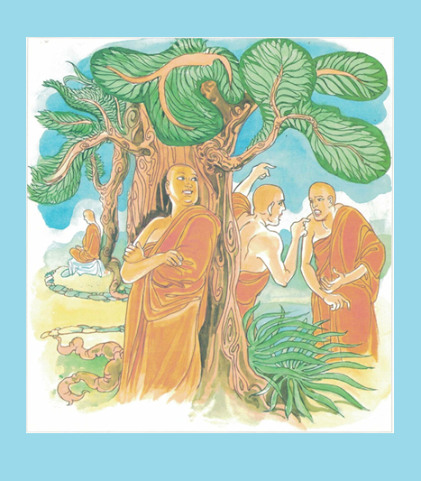

**Dispute in Kosambi: bhikkhus quarrelling and brawling and stabbing each other with verbal draggers [31]**

### How the People of Kosambī Censured the Sangha for Their Dispute

According to the scriptures, after three unsuccessful attempts to reconcile the divided Sangha in Kosambī, the Buddha decided to leave the city. [32]

The Vinaya Pitaka recounts the event as follows:

Before long, the lay followers of Kosambī began to reflect:  
*"These venerable monks have brought great misfortune upon us. Even the Buddha himself, troubled by their quarrels, has departed. In that case, let us take a stand—let us neither bow to them, nor rise in their presence, nor greet them with joined palms. We shall withhold our reverence and cease offering them alms-food. If they are deprived of support, they will have no choice but to either leave, disrobe, or reconcile with the Buddha."*

And so, the laypeople followed through with their decision.

In no time, the monks of Kosambī, realizing the consequences of their actions, said among themselves, *"Let us go to Sāvatthī and resolve this legal issue in the presence of the Buddha."*

With that, they put their dwellings in order, gathered their bowls and robes, and set off for Sāvatthī.[33]

The Vinaya Pitaka provides a detailed account of how the dispute between the two groups of bhikkhus from Kosambī was resolved. [34]

That was the account of the ninth rainy season of the Buddha. Next, we will describe the tenth vassa, which the Buddha spent in solitude in the Parileyyaka Forest.

**The Tenth Rainy season**

According to the scriptures, the Buddha spent this vassa alone in the Parileyyaka Forest. The following suttas confirm this. [35]

|  |
| --- |
| *“On one occasion the Blessed One was dwelling at Kosambi in Ghosita's Park.* |
| *Then, in the morning, the Blessed One dressed and, taking bowl and robe, entered Kosambi for alms.*  *When he had walked for alms in Kosambi and had returned from the alms round, after his meal he set*  *his lodging in order himself, took his bowl and robe, and without informing his personal attendants,*  *without taking leave of the Bhikkhu Saṅgha, he set out on tour alone, without a companion.”* |

Earlier, we saw that the Blessed One attempted to reconcile the two factions of the Sangha, who were divided over a minor disciplinary matter, but his efforts were unsuccessful. As a result, the Buddha decided to leave Kosambī alone. [36]

Noticing the Buddha’s departure, a certain bhikkhu asked Venerable Ānanda whether they should follow him. In response, Venerable Ānanda said:

“Friend*, whenever the Blessed One sets out like that he wishes to dwell alone. On such an occasion the Blessed One should not be followed by anyone.” [37]*

The Blessed One journeyed in stages and eventually arrived at Parileyyaka. There, in the Parileyyaka Forest, he resided at the foot of a sacred sal tree. [38].

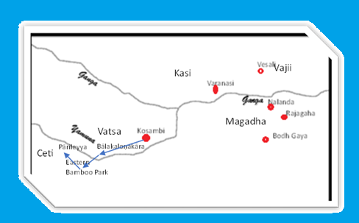

**Map showing the walking tour of the Buddha**

**Note**: From Kosambȋ to Bālakaloṇakāra Village, then to Eastern Bamboo Park and from there to Pārileyya forest . Kosambȋ: where the Buddha spent his 9th rainy season. During the time of the Buddha, it was the capital of the Vatsa /[Vaṃsa](https://www.aimwell.org/DPPN/vamsa.html). Distance between Kosambȋ to Varanasi is about 200 km. Bālakaloṇakāra village was located beside a forest grove near Kosambȋ. Eastern Bamboo Park-Pācīnavaṃsamigadāya **(**Pācīnavaṃsadāya): a park in the [Cetiya](https://www.aimwell.org/DPPN/ceti.html) kingdom (one of the 16 mahajanapada during the time of the Buddha).The park lay between [Bālakaloṇakāra-gāma](https://www.aimwell.org/DPPN/balakalonakarama.html) and the [Pārileyyakavana](https://www.aimwell.org/DPPN/parileyya.html) [39]

The following sources also confirm that the Buddha spent his rainy season in the Pārileyya Forest.

1) “The tenth in the Pārileyyaka grove (dasamaṁ Pārileyyakavanasaṇḍe)[40]

2) “To quieten the great dispute amongst the monks, in the tenth Rains Retreat, the Noble Sage dwelt with the noble elephant in the noble, extensive, spotless Pārileyya forest, which was strewn with flowers.” [41] (Tesaṁ yatīnaṁ mahanta-kalahaṁ samituṁ, dasamamhi Vasse, Muni-Varo vāraṇa-varaṁ nissāya puppha-abhikiṇṇa-vipulā-amala-kānanasmiṁ vara-Pārileyye vāsaṁ akā)

## Important Events Occurred After the Buddha left Kosambȋ

Meeting Venerable Bhagu **[42]**

Traveling alone, the Blessed One arrived at the village of Bālakaloṇakāra, [43] where Venerable Bhagu was residing at the time. [44] After an exchange of cordial words, the Blessed One instructed and uplifted Venerable Bhagu with a discourse on the Dhamma. Having done so, he rose from his seat and continued his journey to the Eastern Bamboo Park.

Meeting Venerable Anuruddha, Nandiya, and Kimmila (Kimbila) **[45]**

When the Buddha arrived at the Eastern Bamboo Park, he found three of his disciples—Anuruddha, Nandiya, and Kimbila—residing there. Delighted by their teacher’s visit, they warmly welcomed him, performed the customary duties, paid homage, and then sat respectfully to one side. The Buddha then asked them whether they were living in harmony and free from disputes.

#### Living in harmony

“*I hope, Anuruddha, that you are all living in concord, with mutual appreciation, without*

*disputing, blending like milk and water, viewing each other with kindly eyes.*”[46]

Venerable Anuruddha replied:

*“…we are living in concord, with mutual appreciation, without disputing, blending like milk*

*and water, viewing each other with kindly eyes.” [47]*

They affirmed that, in accordance with the Buddha’s teachings, they lived together following the ‘**Six Principles of Cordiality.**’

Venerable Anuruddha further said:

*“I think like this, how fortunate I am to be living with such fellow monastics!’ And I do acts of good will toward them by body, speech, and mind, both in public and in private. I think, why don’t I set aside what I wish to do and instead do what these venerables wish? And*

*That’s what I do. We’re separate in body, but it might seem as if we’re one in mind.”*

Venerables Nandiya and Kimbila affirmed Venerable Anuruddha’s statement.

### Living the Spiritual Life with Heedfulness and Energy

The Blessed One then asked whether they were living with heedfulness and diligence.

The venerables replied:

"Whoever returns first from the alms round in the village prepares the seats and sets out water for washing the feet, as well as drinking and washing water. Whoever returns last may eat the leftovers or discard them, then puts away the seats, clears the remaining water, washes the bowl for leftovers, and sweeps the dining hall. If any of us notices that the pots for drinking water, washing water, or the restroom water pot are empty, he refills them. If he is unable to do so alone, he signals another to help, and together, they complete the task. We do all this in silence, without unnecessary speech. Additionally, every five days, we sit together for the entire night to discuss the Dhamma.”

Hearing this, the Buddha rejoiced and said approvingly, *“Good, good, Anuruddha.”*

According to the Buddha’s teaching that is the way community of Sangha should live and support each other for the enhancement of spiritual path.

The Buddha instructed the three venerables through the Upakkilesa Sutta**.** [48]

He inquired about the progress of their meditation practice and taught them how to overcome the mental impurities (*cittassa upakkileso*) that can hinder meditation. The Buddha emphasized to his disciples that these impurities must be abandoned in order to cultivate deep states of meditation (the four jhānas), which ultimately lead to liberation.

#### Summary of the Discourse:

The Buddha revealed to the three venerables the factors that hinder the development of Samadhi: doubt, inattention (not focusing the mind on the object of meditation), fear, excessive joy, lack of interest in achieving Samadhi, excessive energy, insufficient energy, intense desire (for Samadhi), focusing the mind on various signs, and excessive attachment to forms. By eliminating these obstacles, one can attain the four jhānas, which lead to insight. The Buddha also shared how, before his enlightenment, he practiced and gradually abandoned these imperfections, eventually achieving liberation through deep meditation.

Concluding his sermon, the Blessed One said:

*“When, Anuruddha, I had developed Samadhi with applied thought and sustained thought… when I had developed Samadhi accompanied by equanimity, the knowledge and vision arose in me: ‘My deliverance is unshakeable; this is my last birth; now there is no renewal of being.’”[49]*

That is what the Buddha said. The three venerables were pleased and delighted by the Blessed One’s words.

According to the scriptures, at the time this discourse was given, the three venerables were still striving for liberation. Following the Buddha’s instructions, they practiced diligently and ultimately attained arahantship. [50]

## **Significant Events at Pārileyyaka Forest**

According to the commentary, the residents of Pārileyyaka constructed a leaf hut for the Blessed One in a secluded grove near their town. An auspicious (*bhadda* ) sal tree grew there. While living in depending on the town for alma, the Blessed One lived at the foot of this tree, close to the leaf hut in the grove. [51]

The Vinaya Pitaka provides an account of the Buddha choosing to stay alone in the forest, away from the hustle and bustle of the city and the tense atmosphere of the monastery in Kosambī, where the Sangha was divided.

Then, while he was reflecting in private, the Buddha thought: *‘Previously, when I was surrounded by those quarrelling monks at Kosambī, I wasn’t at ease. But now that I’m alone, away from those monks, I’m happy and at ease.* ’”[52]

## Pārileyyaka Elephant Meets the Buddha

According to the scriptures, while the Blessed One was dwelling alone under the sal tree in Pārileyyaka Forest, a large bull elephant named Pārileyya lived among a herd of males, females, and young ones. Having grown weary of the herd, he recognized the value of solitude and left them behind, venturing into the forest where the Buddha was residing.

We can imagine the bull elephant seeing the Buddha sitting calmly and, feeling drawn to his presence, rushing to care for him. Despite being a beast, the elephant may have sensed the Buddha’s great compassion. According to the scriptures, the bull elephant attended to the Blessed One by using his trunk to provide water for drinking and washing, as well as clearing away vegetation. Content to be away from his herd and living near such a noble being, he thought:

*“Previously, when I was surrounded by the other elephants, I was not at ease. But now that I am alone, away from those elephants, I am m happy and at ease.”*

After considering his own seclusion and reading the mind of the elephant, the Buddha uttered a heartfelt exclamation:

*“The mind of this mighty elephant,*

*With tusks like chariot poles,*

*Agrees with the mind of the Sage,*

*Since they each delight in the forest solitude.”[53]*

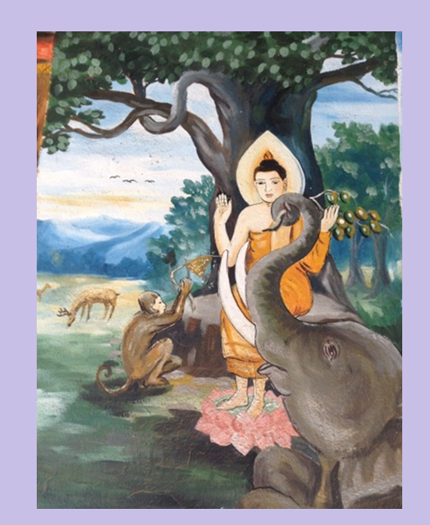

**During the Buddha’s solitary stay in the Pārileyyaka Forest, an elephant and a monkey offer him food and water** [54]

Legends say that during the time the Blessed One spent his vassa in the Pārileyyaka Forest an elephant and a monkey looked after him with love and devotion [55]

#### Another significant Dhamma teaching from this period is the value of solitude for spiritual growth.

The Blessed One consistently praised the benefits of solitude. He demonstrated this by choosing to live alone in the forest rather than among quarrelsome and unwise people. The Buddha emphasized that it is far better to embrace solitude than to endure discomfort and unhappiness in the company of those who lack wisdom.

Below are some of the Buddha’s teachings that highlight the virtues of solitude:

*“Having drunk the taste of solitude  
and the taste of tranquil peace,  
one is without distress, without evil,  
drinking the taste of rapture in the Dhamma”* (Snp:2.3)

*“ One should train in a solitary seat  
and in the exercise of an ascetic.  
It is solitude that is called munihood.  
If you will delight alone,  
you will light up the ten directions”* Snp:3.11

“*Not despising, not harming, restraint according to the code of discipline, moderation in food, dwelling in solitude, devotion to meditation—this is the teaching of the Buddhas”* Dhp:185

## Five Hundred Bhikkhus Visit the Buddha

The *Pārileyya Sutta* (SN 22:81) recounts that a group of five hundred bhikkhus approached Venerable Ānanda and said, “Friend Ānanda, it has been a long time since we last heard a Dhamma talk in the presence of the Blessed One. We would like to hear such a discourse.”

In response, Venerable Ānanda led the bhikkhus to Pārileyyaka Forest, where they paid homage to the Blessed One and sat respectfully to one side. The Buddha then instructed and uplifted them with a Dhamma discourse. *”[56]*

Soon after, a certain bhikkhu asked, “How should one understand and see in order to bring about the immediate destruction of the taints?”

In response, the Buddha provided a detailed discourse, explaining the path to eradicating the taints and attaining arahantship. [57]

The Buddha concluded the discourse with these words:

**“**Bhikkhus, that formation is impermanent, conditioned, and dependently arisen; that craving is impermanent, conditioned, and dependently arisen; that feeling is impermanent, conditioned, and dependently arisen; that contact is impermanent, conditioned, and dependently arisen; that ignorance is impermanent, conditioned, and dependently arisen. When one understands and sees this clearly, bhikkhus, the immediate destruction of the taints takes place**.”** *[58]*

### End of the Tenth Rainy Season

After staying at Pārileyyaka for as long as he wished, the Buddha set out on his journey toward Sāvatthī. Upon his arrival, he took residence in Jeta Grove, at Anāthapiṇḍika’s Monastery. [59]

We will conclude this section here. In the next section (15-4), we will explore where the Buddha spent his eleventh and twelfth rainy seasons and the Dhamma teachings given during that period.

### End Notes: Section 15-3

1. Source 1: Madhuratthavilāsinī (Buddhavaṁsatthakathā) of Bhadantâcariya Buddhadatta Mahathera: Translated by I. B. Honer, 1946.
2. Source 2: Jinacaritaṁ, The Life of the Victorious Buddha, translated by Bhikkhu Anandajoti.
3. Chapter 27: The Great Chronicles of the Buddhas by Venerable Mingun Sayadaw.
4. Ibid.
5. Source: Suttacentral.
6. Source: Google.com
7. Source: Wikipedia : https://en.wikipedia.org/wiki/Kosambi
8. Kukkuṭārāma, a monastery in [Kosambī](https://www.aimwell.org/DPPN/kosambi.html), built by the millionaire Kukkuṭa *(q.v.)* DA.i.318, *etc.* Source: Dictionary of Pāli Proper Names by G.P. Malalasekera.
9. VP: Cȋvarakkhandaha:2.4.6.6.
10. Source: Foot Prints in the Dust by Bhante S. Dhammika
11. They are the three beautiful daughters of Māra (in section 4, we have described this event in detail).
12. Snp:4.9 (Māgandiya sutta) translated by Bhikkhu Bodhi. * In AN10:26, Venerable Mahākaccāna has given an exposition to this sutta.
13. In Ud:7.10 mention the death of Queen Sāmāvatī and 500 of her women while the Buddha dwelling near Kosambī, in Ghosita's Monastery.
14. Ud:7.10.
15. The Buddha declared Queen Sāmāvatī as foremost among those who dwell in loving-kindness is Sāmāvatī, see: AN1:261. * Orphaned as a girl, she became the wife of King Udena of Kosambī. Together with the women of the court, she died when her jealous co-wife, Māgandiyā, had the women’s quarters set on fire. The story is in Ud 7:10, 79. Her biographical sketch is in Nyanaponika and Hecker 2003: 285–93, see: AN: Notes: 142.
16. Ud:7.10.
17. MN:48 (Kosambī sutta). * This dispute is described in detail in Vinaya Pitaka, see: Mhakhandaka: Kd10: *Kosambakakkhandhaka.*
18. See: MN: Notes: 491.
19. MN:48 (Kosambī sutta & VN: Kd.10.
20. See: MN: Note: 493.
21. See: MN: Note: 498.
22. MN:48.
23. VN: Kd.10.
24. Ibid.
25. Ibid.
26. Ibid.
27. Ibid.
28. Ibid.
29. VN: Kd.10.
30. AN4: 243.
31. Source: https://vivekavani.com/d163/
32. VP: Kd.10:3. * This incident is also mentioned in MN: 128 (Upakkilesa Sutta).
33. VP:Kd.103.
34. VN: Kd.10.6.
35. SN22:81
36. See: SN:Note:128.
37. SN22:81.
38. Ibid.
39. Source: Dictionary of Pāli Proper Names • G.P. Malalasekera: https://aimwell.org/DPPN/pacinavamsamigadaya.html
40. Source 1: Madhuratthavilāsinī (Buddhavaṁsatthakathā) of Bhadantâcariya Buddhadatta Mahathera: Translated by I. B. Honer, 1946.
41. Source 2: Jinacaritaṁ, The Life of the Victorious Buddha, translated by Bhikkhu Anandajoti.
42. He was born in a Sakyan family, renounce lay life with his six clansmen and Upāli the barber. * See section 14:2 for more details.
43. Tradition says this was a place near Kosambȋ during the time of the Buddha. * VP:Kd10:3 also mention of the Buddha visiting this place.
44. MN:128 (Upakkilesa Sutta)
45. See section 14:2 for going forth of Venerable Anuruddha and Venerable Kimila/Kimbila. Venerable Nandiya was a constant spiritual friend of the above-mentioned venerables’. MN: 31 (Cūḷagosinga Sutta) mention all three bhikkhus established in arahantship.
46. MN:128. * This event is also described in VP:Kd10:4.
47. MN:128.
48. Ibid.
49. Ibid.
50. See: MN:31 (Cūḷagosinga Sutta)
51. See: SN: Note:129.
52. VP:Kd 10: 5.
53. Ibid. * This story is also described in Ud:4.5.
54. Source: <https://beingheresite.wordpress.com/tag/luang-prabang/>: * pictures from a temple of Luang Prabang, Laos.
55. See: Chapter 28: The Great Chronicles of the Buddhas by Venerable Mingun Sayadaw.
56. Commentary says these bhikkhus( five-hundred )were not involved in the dispute at Kosambi; they have come from other places to live the rainy season with the Buddha.
57. Commentary says: “in this sutta, in twenty-three cases, insight culminating in arahantship has been explained”, see: SN: Note: 137.
58. SN22:81.
59. VP:Kd 10: 5.